In-class exercise: Introduction to Maps

*The file needed for this exercise is* ***restaurants.xlsx***

Your client is a food critic who has been visiting fine restaurants all over the world. She has provided you with an Excel file that includes the exact location of each restaurant (latitude/longitude) that she visited last year, along with other useful information such as the type of cuisine, Michelin star information, etc. Use Tableau to create the following visualizations of this dataset (without the Annotations):

Visualization 1:

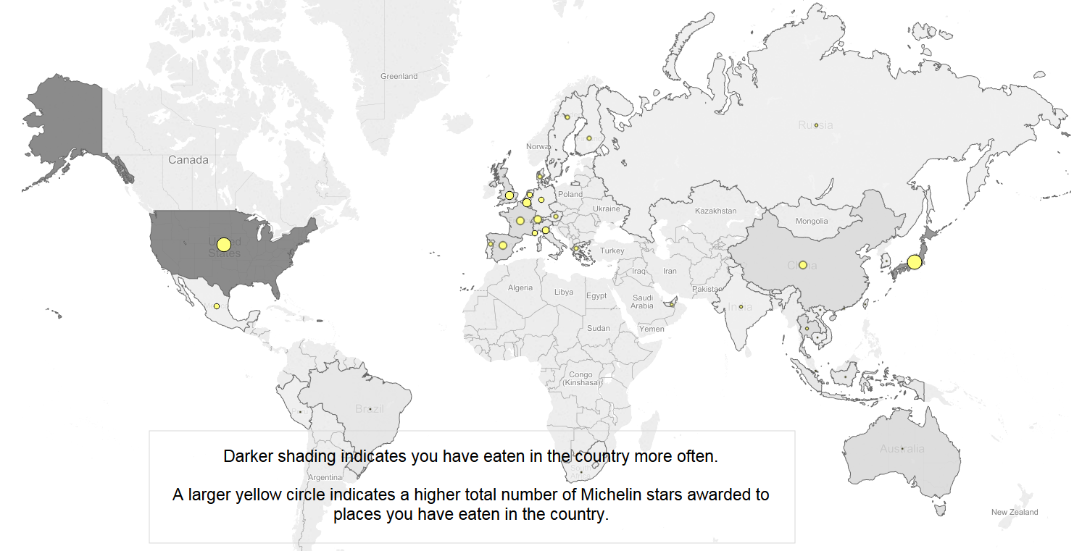

Visualization 2:

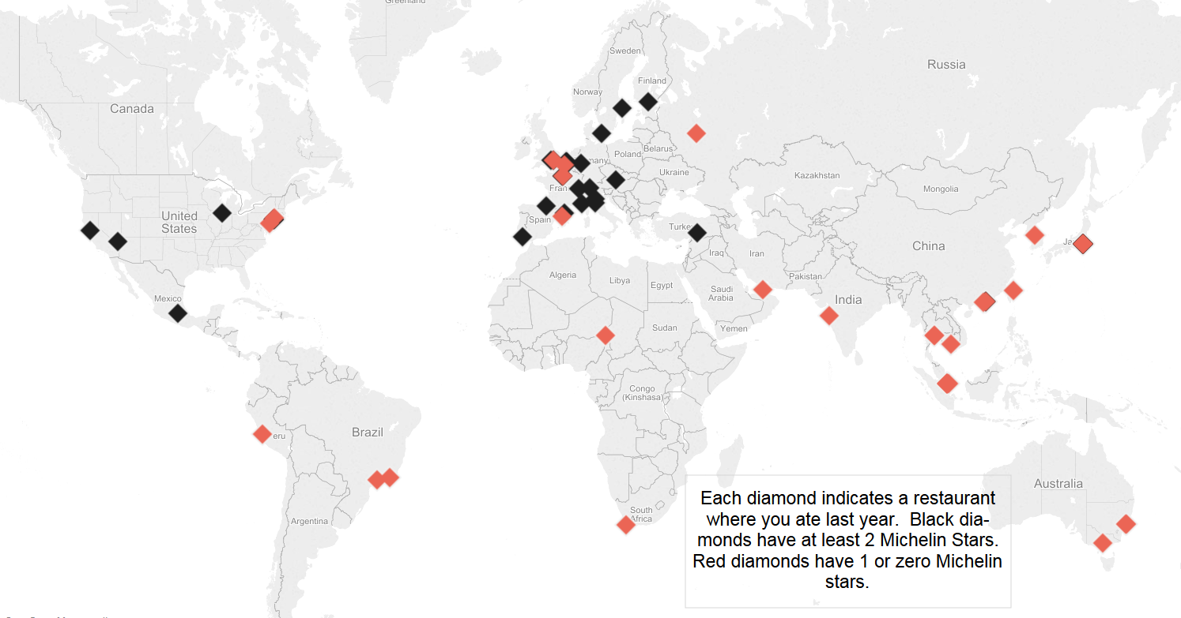

*After successfully creating the two maps above, use the Tableau skills you have learned so far in this course to create at least 2 other interesting visualizations of this data. Be ready to share these with your classmates and explain why you chose the visualization techniques that you used.*

The two maps I created was:

1. How many times a country appears.
2. Chef in different regions.

